DBMS Lab 7

UNION, INTERSECTION, MINUS operators

By: Ishita Bharadwaj

SRN: PES1UG20CS648

Section: K

Roll No: 43

1. Find the list of passengers (user_id, user_type First name and last name) who have travelled from Bengaluru to Chennai during the month of Oct 2021 and Aug 2022.

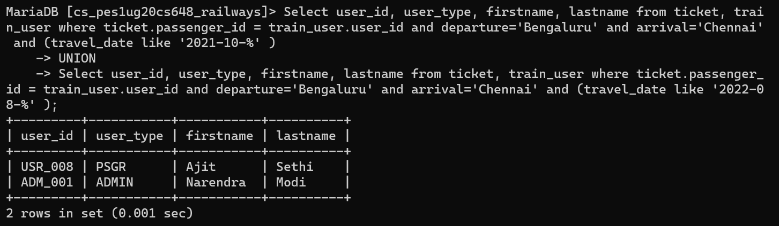

1. Find the list of passengers (user_id, user_type First name and last name) who have traveled from Bengaluru to Chennai during the month of Oct 2021 and also during Aug 2022.

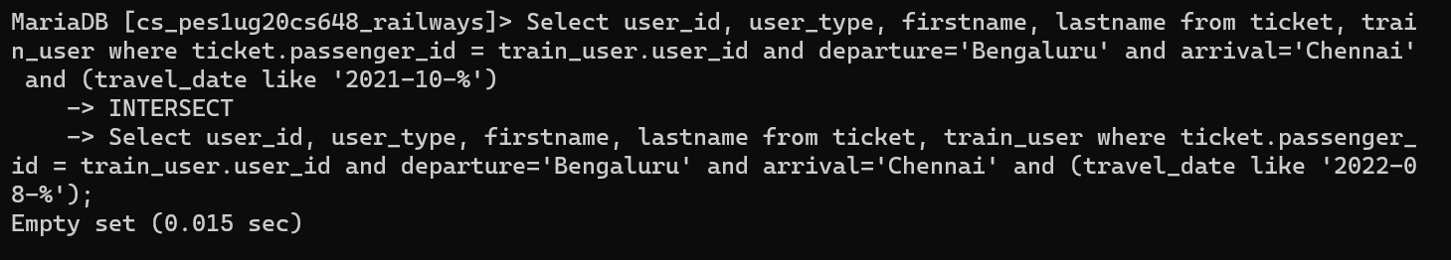

1. Find the list of passengers (user_id, user_type First name and last name) who have travelled from Bengaluru to Chennai during the month of Aug 2022 and not in Oct 2021

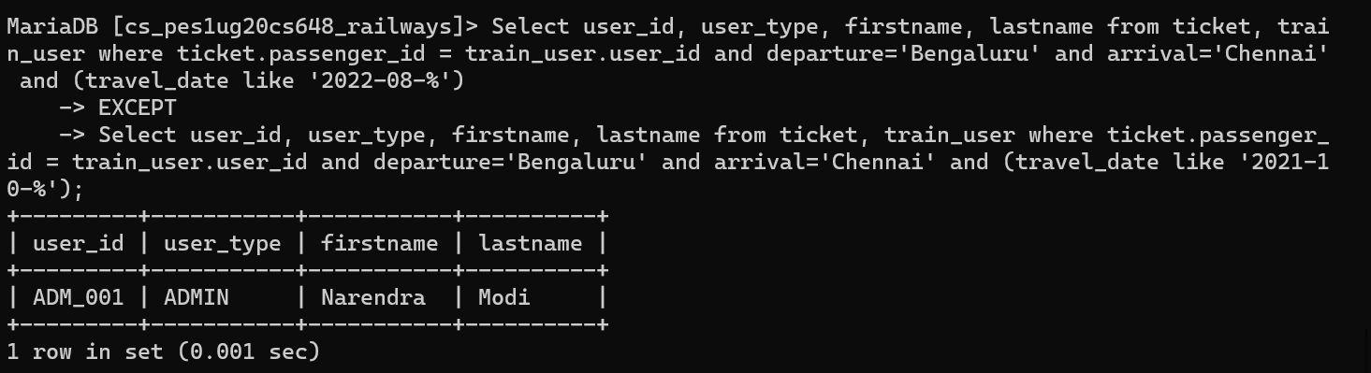

1. Find the list of passengers (user_id, user_type, First name and last name) who have travelled from Bengaluru to Chennai and returned to Bengaluru within a week.

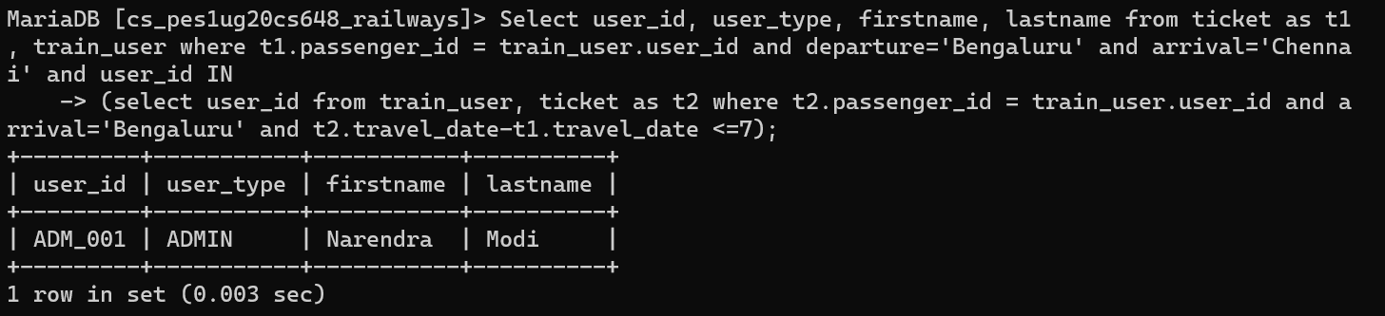

1. Find the list of passengers (user_id, user_type, First name and last name) who have travelled from Bengaluru to Chennai and did not return to Bengaluru (in other words, only one way travel from Bengaluru to Chennai)

